School Photos Schedule
School: | Springfield Lakes State School - Main Job - 2026
Photo Day: | Tuesday 26th May 2026
Photo Organiser: | Rachelle Hay | Version: 5 | Location: Hall
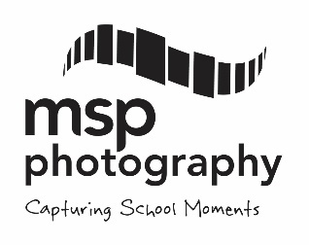
Time | Group Name | MSP Office Use
8.00 | Staff Group Photo
8.00 | Siblings
8.45 | School Leaders Photo (All Captains)
8.50 | 5A
9:00 | 5B
9:10 | PF
9:25 | 5F
9:35 | 5C
9:45 | 5D
9:55 | 4/5K
10:05 | 6G
10:15 | 6A
10:25 | 6B
10:35 | 6C
10.50 | First Break (10.50-11.30)
11:35 | 6D
11:45 | 6E
11:55 | 6F
12:05 | 4D
12:15 | 4E
12:25 | 4A
12:35 | 4B
12:45 | 4F
1.00 | Second Break (1.00-1.30)
1:35 | 4G
1:45 | 3A
1:55 | 3B
2:05 | 3F
2:15 | 3G
2.45 | School Finish

School Photos Schedule
School: | Springfield Lakes State School - Main Job - 2026
Photo Day: | Wednesday 27th May 2026
Photo Organiser: | Rachelle Hay | Version: 5 | Location: Hall

Time | Group 1 | Time | Group 2
8.00 | Siblings
8.45 | School Starts
9:00 | 1E | 9:00 | 1F
9:20 | 1C | 9:20 | 1D
9:40 | PA | 9:40 | PB
10:00 | PC | 10:00 | PD
10:20 | PE | 10:20 | 5E
10.50 | First Break (10.50-11.30) | 10.50 | First Break (10.50-11.30)
11:35 | 1A | 11:35 | 1B
11:50 | 2A | 11:50 | 2B
12:05 | 2C | 12:05 | 2D
12:20 | 2E | 12:20 | 2F
12:35 | 3E | 12:35 | 3D
1.00 | Second Break (1.00-1.30) | 1.00 | Second Break (1.00-1.30)
1:35 | 3C | 1:35 | Senior Strings
1:50 | Senior Band | 1:50 | Junior Strings
2:05 | Junior Band | 2:05
2:20 |  | 2:20
2.45 | School Finish | 2.45 | School Finish

