Cooperative | Peaceful | Respectful
- GO directly to the pick up zone.  - Stand in two lines on the left of the path.  - Join the back of the line.  - Watch for your car- be ready to leave the line.  - Speak to the teacher on duty if you need to leave the line for some reason.  - Have your bag with you ready to leave.  - Wait behind the yellow line until your car has completely stopped.  - Walk on the concrete. | - Speak quietly to others near you.  - Move up peacefully in the line when necessary.  - Wait in line quietly and patiently.  - Keep your hands and feet to yourself.  - Listen carefully and follow teacher instructions. | - Use manners- say “excuse me please” when you need to get past others.  - Respect others’ property and personal space.  - Speak respectfully to all students and staff.

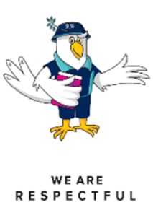
- ------------------------------------------------------------------------------------------------------------------------------------Read this through with your parents. Have them sign, then return the slip to a pick up zone teacher for a chance to win a tuckshop voucher.

Child’s name :______________________________________

Parent’s signature : _________________________________

Springfield Lakes State School: Pick up zone

